TCP/IP Configuration

- Connect the reader to PC and supply for the reader.（Connection: TCP IP）

- Install and run ZNetCom software.

- Click on Search
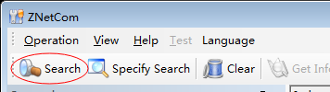

- The follow screen as below:
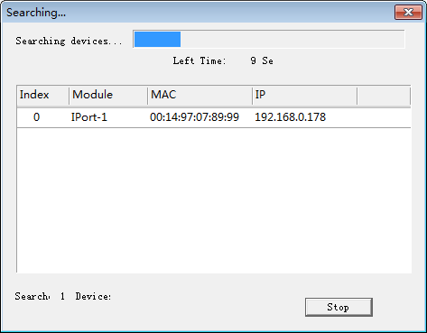

- Then double-click the goal, as illustrated below:
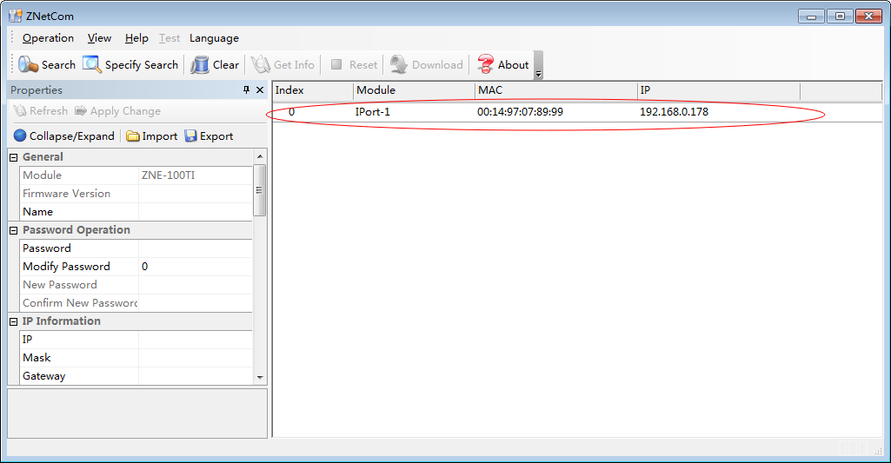
- Information of Reader will be displayed on the left:
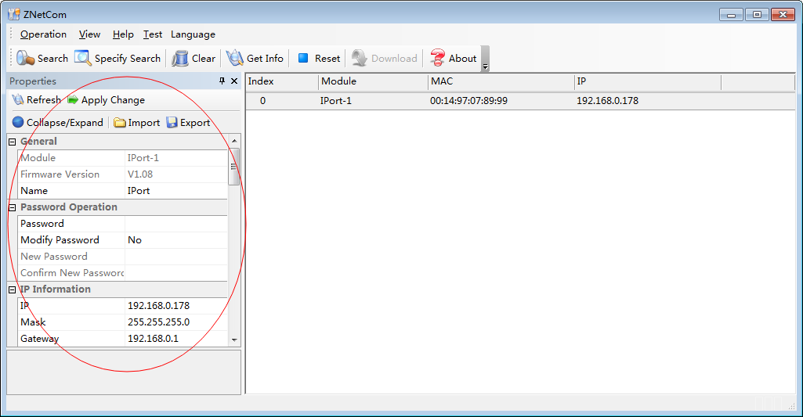

- Input pass word in here (pass word : 88888) :
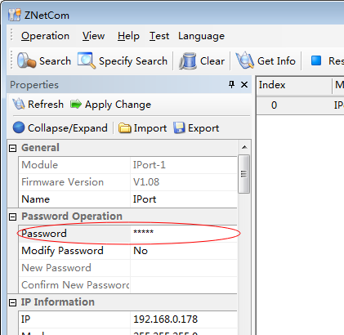

- IP Information can be changed in here as below:
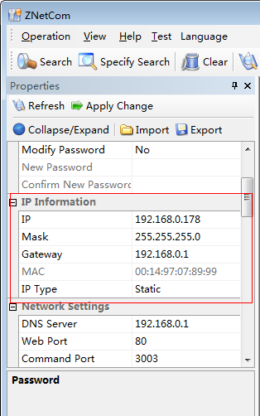
- Baudrate can be changed in here as below:
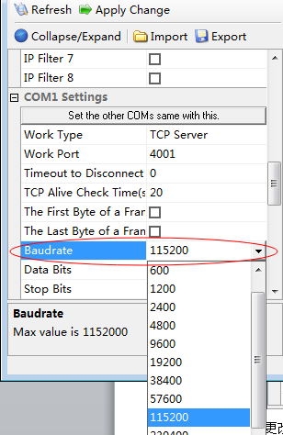

- Every changes are finished, please click on Apply Change.
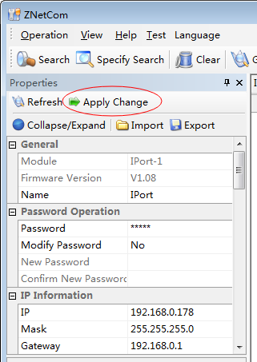

Then we can connect Reader to PC via TCP/IP.

